**Mod 2: Critical Thinking**

Alex Mehler

CSU Global

CSC372-1

Dr. Coope

April 1, 2024

**Execution:**

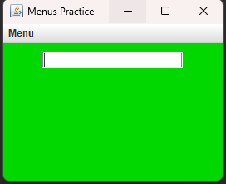

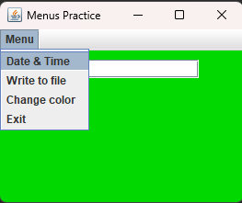

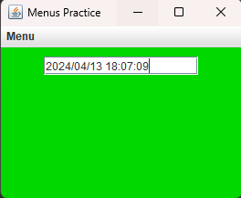

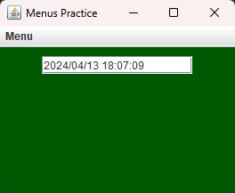

**Code:**

import java.awt.EventQueue;

import java.awt.Color;

import javax.swing.JFrame;

import javax.swing.JMenu;

import javax.swing.JMenuBar;

import javax.swing.JMenuItem;

import javax.swing.JPanel;

import javax.swing.JTextField;

import javax.swing.border.EmptyBorder;

import java.awt.event.ActionEvent;

import java.awt.event.ActionListener;

import java.io.FileWriter;

import java.io.IOException;

import java.time.LocalDateTime;

import java.time.format.DateTimeFormatter;

public class Menus extends JFrame implements ActionListener {

private static final long ***serialVersionUID*** = 1L;

private JPanel thePanel;

private static JMenuBar *menuBar*;

private JMenu menu;

private JMenuItem menuItem;

private JMenuItem menuItem1;

private JMenuItem menuItem2;

private JMenuItem menuItem3;

private JTextField text;

public static Color randColor(){

int r = 0;

int g = (int)(Math.*random*()*256);

int b = 0;

return (new Color(r,g,b));

}

/**

* Launch the application.

*/

public static void main(String[] args) {

EventQueue.*invokeLater*(new Runnable() {

public void run() {

try {

Menus frame = new Menus();

frame.setVisible(true);

frame.setJMenuBar(*menuBar*);

} catch (Exception e) {

e.printStackTrace();

}

}

});

}

public Menus() {

setTitle("Menus Practice");

setDefaultCloseOperation(JFrame.***EXIT_ON_CLOSE***);

setBounds(100, 100, 280, 227);

thePanel = new JPanel();

thePanel.setBorder(new EmptyBorder(5, 5, 5, 5));

thePanel.setBackground(*randColor*());

setContentPane(thePanel);

text = new JTextField();

text.setBounds(82, 100, 86, 20);

thePanel.add(text);

text.setColumns(15);

*menuBar* = new JMenuBar();

menu = new JMenu("Menu");

menuItem = new JMenuItem("Date & Time");

menuItem1 = new JMenuItem("Write to file");

menuItem2 = new JMenuItem("Change color");

menuItem3 = new JMenuItem("Exit");

menu.add(menuItem);

menu.add(menuItem1);

menu.add(menuItem2);

menu.add(menuItem3);

*menuBar*.add(menu);

menuItem.addActionListener(new ActionListener() {

//@Override

public void actionPerformed(ActionEvent e) {

// print date

DateTimeFormatter dtf = DateTimeFormatter.*ofPattern*("yyyy/MM/dd HH:mm:ss");

LocalDateTime now = LocalDateTime.*now*();

text.setText(dtf.format(now));

}

});

menuItem1.addActionListener(new ActionListener(){

// @Override

public void actionPerformed(ActionEvent e) {

// write to file

DateTimeFormatter dtf = DateTimeFormatter.*ofPattern*("yyyy/MM/dd HH:mm:ss");

LocalDateTime now = LocalDateTime.*now*();

try {

FileWriter writer = new FileWriter("C:/Users/maste/OneDrive/Documents/CSU Global/Java 2/mod 3/textfile.txt");

writer.write(dtf.format(now));

writer.close();

}

catch (IOException e1) {

System.***out***.print(e1.getMessage());

}

}

});

menuItem2.addActionListener(new ActionListener() {

*@Override*

public void actionPerformed(ActionEvent e) {

// **TODO** Auto-generated method stub

thePanel.setBackground(*randColor*());

}

});

menuItem3.addActionListener(new ActionListener() {

*@Override*

public void actionPerformed(ActionEvent e) {

// **TODO** Auto-generated method stub

System.*exit*(0);

}

});

}

*@Override*

public void actionPerformed(ActionEvent e) {

// app gets mad if this method is not here

}

}

**Git:**

https://github.com/SevRnce/P2-Mod-2